Briefly explain the difference between waterfall and spiral models. Are there any common characteristics for both the models?

A: Waterfall is finishing one and then pass to the next one, and step by step downward. But spiral is agile method with process: plan design develop test deploy feedback and then plan again.

How does Extreme Programming (XP) improve a software project and what is its most important factor of success as compared to traditional software development methods? (what is extreme programming?)

Draw a use case diagram for a ticket distributor for a movie theatre. The system includes two actors: a movie watcher who purchases different movie tickets, and a central computer system that maintains a reference database for the ticket price and cinema type. Use cases should include BuyGeneralTicket, BuyiMAXTicket, BuyLUXTicket, UpdateTicketPrice, UpdateMovieSession and SelectMovieSession. Also include the following exceptional cases: TimeOut (i.e., movie watcher took longer than 10 minutes to complete the process), TransactionAborted (i.e., movie watcher selected the cancel button without completing the process), CreditCardTransactionFailure, SessionFull and SystemOutOfPaper. (you forgot extend and include relationship)

Question 4: Draw a class diagram representing a banking system defined by the following statement: 3 marks Each bank has location, unique code and a manager. A bank has many customers and each customer can open maximum of two bank accounts: saving account or current account. A customer has name, address, mobile number, card number and pin code for his account(s). Each bank account (either saving or current) has unique account number and belongs to a particular customer. Customers can deposit or withdraw cash from any of his or her bank accounts. You must add an abstract class and an inheritance relationship to factor out common attributes into the abstract class (if required). (You forgot inheritance and abstract class, you forgot what is the rule of class diagram)

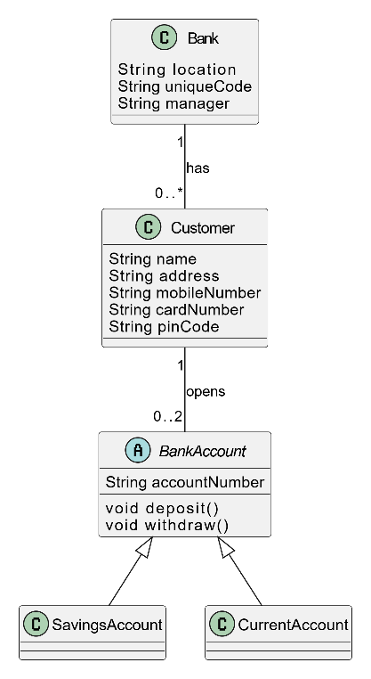

Question 5: 3 marks Draw a sequence diagram for the warehouseOnFire scenario provided below. Include the objects bob, alice, john, FRIEND (First Interactive Emergency Navigational Database), and instances of other classes you may need (read how to do it)

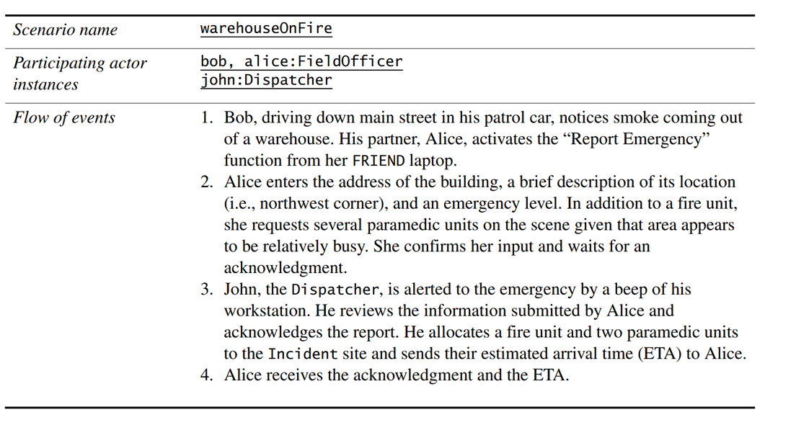

Question 6: 2 marks

A head torch worn by bicyclist is controlled by two switches A and B. Switch A switches OFF the light while switch B switches it ON. The head torch can be in one of the following modes: low intensity, high intensity and blinking. The modes of head torch can be changed in the order it is presented by pressing switch B repeatedly. The head torch is always in low intensity mode when switched ON. Draw a UML statechart diagram to show a design for the head torch which allows full control of the head torch from the two switches.

Question 7:

5 marks

Write the name of the most relevant software design pattern in front of each of the natural language heuristics for the software product.

• The product must be platform and manufacturer independent

• The product must be able to support future protocols

• The product must comply with existing software and must reuse existing legacy component

• All transactions should be logged in the system and be undoable

• The product must allow different algorithms to be interchanged for a task

SECTION II

Question 8:

3\*3 marks

1. Describe three functional requirements for the system
2. The system should be able to read card
3. Should be able to touch screen (WRONG)
4. Should be able to calculate number of bowling based on card limit
5. Describe three non-functional requirements for the system. (you should remember non fucnional general answer for this question)

* Performance speed: should be quick to load card bank server
* Authentication should be security
* touch-display terminal should be user-friendly

1. Give a prioritized list of design constraints for the system and justify your list and the ordering. (Remember what is design constraints)

Question 9:

4\*2 marks

1. Describe a software architecture that would be suitable for the system.

MVC (WRONG! Right answer is Client-Server Architecture:)

b) Present a structured rationale argument for your software architecture using the design

constraints that you identify in Question 8 (c) above. (you should remember the argument of each arch)

Question 10:

5\*2 marks

1. Propose a set of classes that could be used in your system and present them in a class diagram.

Credit card/ Customers/ bowling games/ bowling lane/

1. Propose a subsystem decomposition for these classes and comment on the coupling and cohesion

Low coupling high cohesion

within this decomposition.

Question 11:

3 marks

Identify two design patterns that would be suitable for the system. Briefly justify your selection.